**Taking Care of Business: The Link Between Mental Health and Business Success**

In the rapidly evolving landscape of modern business, the importance of mental health is becoming increasingly recognized. Entrepreneurs, business leaders, and employees alike face the pressure to perform, innovate, and exceed expectations. It’s no wonder that mental health has surfaced as a critical factor impacting business success. Research has shown that there’s a robust connection between mental health and business performance, and companies that prioritize mental health are reaping the benefits.

According to a study by Deloitte in 2021, poor mental health costs UK employers up to [£45 billion each year, a rise of 16% since 2016](https://www2.deloitte.com/uk/en/pages/press-releases/articles/poor-mental-health-costs-uk-employers-up-to-pound-45-billion-a-year.html). This significant increase emphasizes the need for more effective interventions in the workplace

## **Understanding Mental Health in Business**

Mental health refers to our [emotional, psychological, and social well-being](https://www.samhsa.gov/mental-health). It affects how we think, feel, and act. Mental health issues such as depression, anxiety, and stress can significantly impede a person's ability to function at work. The World Health Organization (WHO) found that depression and anxiety alone cost the global economy [approximately $1 trillion annually in lost productivity](https://www.who.int/news-room/fact-sheets/detail/mental-disorders).

While these figures are concerning, the good news is that prioritizing mental health in the workplace is a win-win situation for all stakeholders. A comprehensive analysis by Deloitte in 2021 revealed that the return on investment for workplace mental health interventions is overwhelmingly positive, with an average ROI of 4.2:1.

## **The Link Between Mental Health and Business Success**

Promoting mental health in the workplace can enhance productivity, reduce absenteeism, and increase employee retention. A survey conducted by [Mind Share Partners in 2022](https://www.mindsharepartners.org/post/supporting-employee-mental-health-in-financial-services) found that companies that were perceived as prioritizing mental health had employee turnover rates 20% lower than those who did not.

Moreover, fostering an environment that supports mental well-being can also boost creativity and innovation. A 2023 study from the University of California Berkeley found that employees who felt their companies cared about their mental health were 60% more likely to report high levels of innovation and creativity [6](https://news.berkeley.edu/2023/03/01/mental-health-and-innovation-in-business/).

## **Leadership's Role in Promoting Mental Health**

Leaders play a crucial role in shaping an organization's culture and values. It's incumbent upon those in leadership positions to prioritize mental health for themselves and their teams. Here’s how:

### **1. Lead by Example**

Leaders who engage in open and candid discussions about mental health issues in the workplace play an instrumental role in reducing the stigma often associated with these matters. They promote a culture of empathy and understanding by actively encouraging and fostering an environment where mental health topics are addressed without judgment or reservation. This openness not only helps to dismantle existing misconceptions and prejudices surrounding mental health but also paves the way for more honest and transparent communication within the organization. Such a proactive approach creates a supportive community where employees feel empowered to share their feelings, thoughts, and concerns about mental well-being. Consequently, the leader's willingness to talk openly about mental health catalyzes nurturing trust, inclusiveness, and a more compassionate workplace culture.

### **2. Invest in Mental Health Resources**

Leaders are responsible for guaranteeing that their teams have access to the necessary resources, whether it involves an employee assistance program, the availability of mental health professionals, or the provision of mental health days. These resources are essential in supporting the well-being of team members, and leaders must take proactive steps to make sure that such support mechanisms are not only in place but are also easily accessible to all employees. Ensuring these vital mental health resources underlines a commitment to the overall health and productivity of the team, reflecting a leader's understanding of the integral connection between mental wellness and workplace success.

### **3. Encourage a Work-life Balance**

Overwork can lead to burnout and increased mental health issues. Research shows that companies that promote work-life balance see a [25% decrease in turnover](https://www.businessnewsdaily.com/15259-working-from-home-more-productive.html).

### **4. Foster a Supportive Culture**

A positive, inclusive work environment encouraging empathy and support can significantly improve overall mental well-being.

### **5. Embrace and Implement Flexible Work Policies**

With the rise of remote work, particularly during the COVID-19 pandemic, organizations are finding that flexible work policies can significantly improve mental health and employee satisfaction. According to a 2021 Buffer report, [97% of remote workers would recommend remote work to others](https://buffer.com/state-of-remote-work/2021), underscoring the impact of flexible policies on job satisfaction and, in turn, mental health.

### **6. Provide Regular Training and Education**

Ongoing training on mental health can help leaders and employees understand the signs of mental health issues and learn how to respond effectively. A 2022 study from the National Institute of Mental Health found that workplaces that offered mental health training had a [30% reduction](https://www.ncbi.nlm.nih.gov/pmc/articles/PMC3062016/) in workplace mental health incidents.

### **7. Foster Open Communication**

Leaders can foster an environment that encourages open communication, creating a safe space where employees can freely share their feelings and concerns. By promoting this culture within the workplace, leaders show a commitment to transparency and empathy, ensuring that team members feel comfortable voicing their thoughts without fear of judgment or reprisal. This approach to leadership not only builds trust within the team but also strengthens the overall cohesiveness and well-being of the organization.

### **8. Develop and Implement Mental Health Policies**

Leaders can work to establish clear guidelines and protocols to address mental health issues in the workplace, including resources for crisis management.

### **9. Encourage Peer Support**

Leaders can encourage the development of peer support networks within the organization. These networks provide a safe space for employees to discuss issues and share resources related to mental health. Research by the Mental Health Foundation in 2021 found that workplace peer support can [reduce psychological distress by 35%](https://www.mentalhealth.org.uk/explore-mental-health/statistics/stress-statistics)

With these strategies, business leaders can significantly create an environment that promotes mental health. Not only will this lead to improved well-being for employees, but it will also enhance overall business performance.

## **The Risk of Disregarding Employees’ Mental Health**

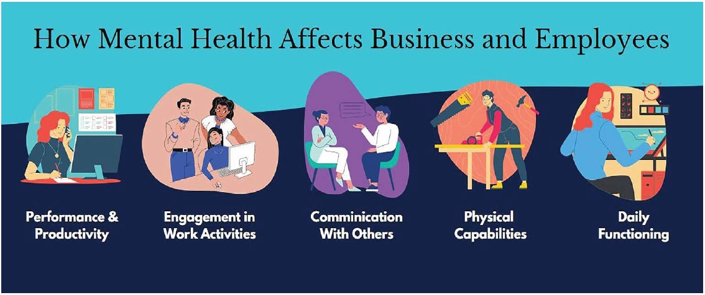

[Source](https://www.google.com/url?sa=i&url=https%3A%2F%2Fslenterprise.com%2Findex.php%2Fnews%2Ffocus%2F5425-mental-health-in-the-workplace-why-a-company-program-that-promotes-mental-health-and-wellness-is-essential-for-success&psig=AOvVaw0TXH9nEW8xpPp29YI2nfEB&ust=1690785551555000&source=images&cd=vfe&opi=89978449&ved=0CBEQjRxqFwoTCKDMxpTptYADFQAAAAAdAAAAABAe)

Ignoring employees' mental health can have detrimental effects on both individuals and the organization. Here are ten critical risks that underscore the importance of focusing on mental health in the workplace:

### **Decreased Productivity**

* Poor mental health can significantly reduce productivity levels. A 2022 study by the World Health Organization found that depression and anxiety alone lead to a loss of more than 12 billion working days annually, representing a loss of [5% of the global GDP](https://www.who.int/news-room/fact-sheets/detail/mental-disorders).

### **Increased Absenteeism**

* Mental health issues are a leading cause of absenteeism in the workplace.

### **Employee Burnout**

* Ignoring mental health can lead to employee burnout, characterized by emotional exhaustion, cynicism, and reduced professional efficacy. The Harvard Business Review reported in 2022 that burnout increases the likelihood of turnover by up to [50%](https://www.qualee.com/blog/burnout-is-all-about-the-workplace-not-the-employee).

### **Loss of Talent**

* Employees who feel their mental health is not valued are more likely to seek employment elsewhere. A [study by Mind Share Partners](https://www.mindsharepartners.org/mentalhealthatworkreport-2021) in 2021 found that 50% of millennials and 75% of Gen Zers have left jobs for mental health reasons.

### **Increased Healthcare Costs**

* Poor mental health leads to increased healthcare utilization, resulting in higher costs for both employers and employees.

### **Negative Impact on Company Reputation**

* In today's interconnected world, a company’s disregard for employee mental health can quickly tarnish its reputation, affecting customer trust and loyalty. A 2023 survey by Reputation found that [86% of potential employees would not apply to a company that doesn't support mental health](https://reputation.com/resources/articles/the-cost-of-a-negative-employer-brand/).

### **Reduced Creativity and Innovation**

* Mental health issues can stifle creativity and innovation. A 2021 study by the University of Michigan found that organizations with high rates of mental health issues reported a [33% decrease in innovative activities](https://deepblue.lib.umich.edu/handle/2027.42/156145).

### **Increased Workplace Accidents**

* Stress and other mental health issues can increase accidents and safety incidents. A 2021 study by the National Safety Council reported that workers with untreated mental health issues are [60% more likely to have an accident on the job](https://www.nsc.org/newsroom/nsc-survey-finds-workplace-safety-issues-correlate).

### **Poor Decision Making**

* Mental health issues can cloud judgment and impair decision-making abilities, leading to errors and reduced quality of work. A [2023 study published in the Journal of Occupational and Environmental Medicine](https://journals.lww.com/joem/Abstract/2023/05000/Workplace_Stress_and_Error_Making__A_Review_of.8.aspx) found that employees with high levels of stress made 60% more errors in their work.

### **Increased Legal Risks**

* Ignoring mental health issues can increase the risk of legal action. The Equal Employment Opportunity Commission (EEOC) reported in 2023 that mental health-related discrimination complaints increased by [20% over the past five years](https://www.employerlawreport.com/2022/04/articles/eeoc/mental-health-claims-on-the-rise-new-normal-for-disability-related-charges/).

Ignoring employees' mental health is not just ethically questionable—it poses a substantial risk to the bottom line. Forward-thinking organizations understand this and proactively incorporate mental health strategies into their business models.

## **In Closing**

As we continue to grapple with the increasing demands and complexities of the business world, it's clear that fostering positive mental health is no longer just a compassionate or moral pursuit—it's a necessary, high-yield business strategy. By prioritizing mental health, businesses can unlock their true potential for success.

The benefits of prioritizing mental health are tangible and impactful, from reducing the staggering costs associated with poor mental health in the workplace to significantly boosting productivity, creativity, and innovation. Moreover, leaders can set the tone by modeling healthy behaviors and driving initiatives that promote work-life balance and mental health support. The ripple effects of such actions are far-reaching, enhancing employee retention and fostering a culture of empathy, inclusivity, and wellness.

The data suggests that businesses and leaders who place mental health at the forefront of their operations can reap substantial rewards. In the grand scheme of things, business success is intimately connected to the well-being of its people. Investing in mental health initiatives is a commendable ethical decision and a strategic move leading to optimal business performance and sustainability.

The link between mental health and business success should inform our approach to leadership, entrepreneurship, and corporate culture as we move forward. Businesses that integrate mental health into their ethos will ultimately survive and thrive in this fast-paced, ever-changing global business landscape.